# PHASE – 3

Project Report for Image Similarity Detection

By -

Krishna Vamsi Nandamuru

Krima Doshi

Nisarg Shah

Harshita Verma

Chinmay Sai Krishna Atluri

Eshita Khandelwal

**SUBJECT:** CSE 515 Multimedia and Web Databases

Arizona State University

28th, November, 2021

# TABLE OF CONTENTS

|  |  |  |
| --- | --- | --- |
| Sr. No | Heading | Page No. |
| 1. | Abstract |  |
| 2. | Introduction |  |
| 3. | Description of Proposed Solution |  |
| 4. | Design Decisions |  |
| 5. | Interface Specification |  |
| 6. | Outputs |  |
| 7. | System Requirements |  |
| 8. | Related Works |  |
| 9. | Conclusions |  |
| 10. | Bibliography |  |

# ABSTRACT

With the introduction of modern technology, Media has become common place in today’s world. Increasing number of devices are being connected to the wider network and are sharing all forms of information that transcend the traditional textual data sharing. From services that provide on-demand videos via the web to personal cloud storage technologies, Multimedia is the new format to share information in this digital age.

With the emergence of multimedia and its dominant presence in the world, Content-based information retrieval has become a necessity to organise and maintain information. It has become a topic of interest for researchers to develop methods to query multimedia data and return relevant results.

A popular implementation of the above defined case is reverse image search, in which a person provides an input image and the recommender systems retrieve similar/relevant images and provide results based on the image.

The main issue we encounter as soon as we deal with multimedia is the constraint of space. As multimedia has a heavy computation cost, we use Dimensionality Reduction Methods as a way to reduce the dimensionality of the data and speed up the processing.

In this project, we describe one such application of multimedia, which is storing and retrieval of images. We use Olivetti faces dataset for working with as a proof of concept and implement an image similarity detection algorithm that extracts specified feature vectors from the input image and uses metric measures to compare the distances between images and determine the most similar.

The Phase-3 of this project concentrates on classifying the given folder of a images using different classifying methods, such as Support Vector Machine, decision tree classifier, PPR based classifier.

We also discuss about the locality-sensitive hashing and VA-files indexing tool, that help us to implement similar image search using the index structure and determine the closest images to a given query image.

Keywords Phase-1: Olivetti face, Feature Extraction, Color Moments, Histogram of Oriented Gradients, Extended Local Binary Patterns, Manhattan Distance, Cosine Distance, Cosine Similarity, Earth Movers Distance, L2 Norm.

Keywords Phase-2: Singular Vector Decomposition, Principal Component Analysis, K-Means, Centroids, Clusters, Object-Feature weights, Latent Dirichlet Allocation, Random Walk, PageRank, Seed nodes, ASCOSS++, Similarity Matrix, Transition Matrix.

Keywords Phase-3: Personalised Page Rank, Locality-Sensitive hashing, VA-files Index, Support Vector Machine, Decision Trees, Relevance Feedback, Classification.

# INTRODUCTION

**1. Terminology**

**Feature Vector**

A Feature Vector can be described as an abstraction of an image used to characterize and numerically quantify the contents of an image. Usually, it takes a real, integer or binary value. It can be described as a list of numbers used to represent an image.

**Color Moments**

Color Moments are simple measures that can be applied to images and differentiate them based on the composition of colours within the image. They are measures that describe a probability distribution of colours for a particular block of pixels. They are mainly used as an indexing feature to quickly retrieve similar images from a database of images, based on their colour features. There are three main components to calculating the color moment feature. They are:

1. Mean

2. Standard Deviation

3. Skewness

The first colour moment “Mean” can be defined as the average colour in the image or the average of the pixel values of each color channel of the image. Mean is calculated using the following formulae:

(N corresponds to the number of pixels in the image & is the value of j’th pixel of i-th color channel)

The second colour moment “Standard Deviation” can be defined as the amount of deviation in the pixel value between corresponding pixels.

( is the mean value or the first color moment and N is the number of pixels in the image)

The third colour moment is the “Skewness” which measures the asymmetry of the colour distribution. Skewness provides information about the shape of the colour distribution of an image. Skewness is calculated as shown below:

( is the mean value or the first color moment and N is the number of pixels in the image)

**Extended Local Binary Patterns**

Local Binary Patterns or LBP is a feature that can be extracted from an image and gives information about the textures found in the image. It is a powerful feature used to classify and index images based on their texture analysis. An LBP Vector is calculated using the following steps:

* Each current window in consideration is divided into a set of cells.
* Each pixel in a cell is compared with n of its neighbours (value of n can be changed).
* If the neighbouring pixel’s value is greater than central pixel, value is considered “1”, otherwise value is “0”.
* Histogram of the frequency of occurrence of these “1”s and “0”s are calculated and normalized.

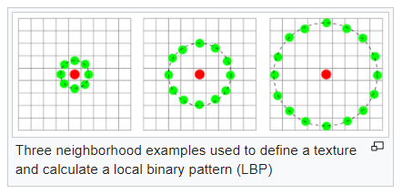

*(Example of the LBP being calculated)*

All such histograms for all blocks of the images are then concatenated into a single vector. The extension to the above described LBP is called uniform pattern, which reduces the length of feature vector. A local binary pattern is called uniform if there are at-most two ‘0-1’ or ‘1-0’ transitions in the patterns. All such patterns are binned into a single bin and rest of patterns are put in separate bins. This greatly reduces the space used to store the feature vector for LBP. Such an operation is called ELBP and is determined to be rotation invariant.

**Histogram of Oriented Gradients**

A gradient can be defined as a smooth or sharp change in the hue and colour of an image in a particular direction. The histogram of oriented gradients or HOG is a feature vector that computes the direction of change depending on the user’s value of the number of directions. The HOG is computed in the following manner:

* Input image is taken
* The gamma and colour values are normalized to [0-1]
* Gradients are computed over the given window
* Weighted votes are cast by each pixel as per the values
* Contrast is normalized over overlapping blocks
* Final HOG is computed over the selected window

The output of HOG is similar to that of edge detection algorithms. HOG also outputs a vector that if visualized more or less computes the edges of the objects in an image as per the colour gradients. A sample image and its HOG Output is as given below:

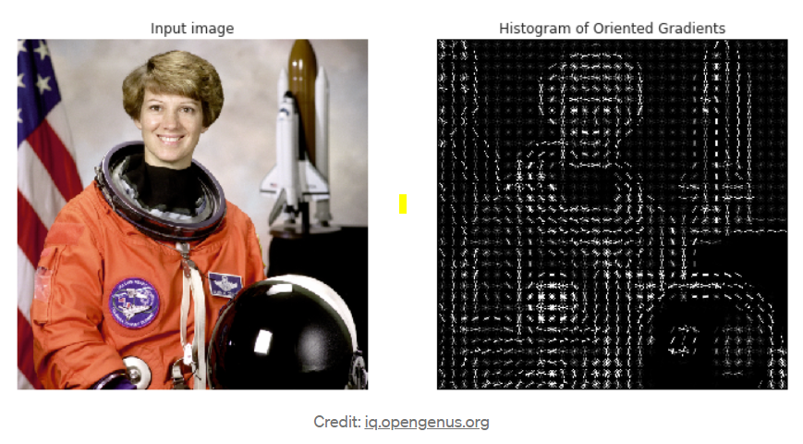

**Principal Component Analysis**

In a data distribution of points plotted on a real coordinate space, Principal components can be defined as a sequence of vectors that denote the maximum variation among points. These components are orthogonal to each other and constitute an orthonormal basis space on which all the points of the space can be projected with a minimal loss in information. Principal Component Analysis (PCA) is the process of computing these components then transforming the data by projecting it on to the most significant among the computed components. The process for computing PCA for a given matrix is as follows:

* For the given n x m matrix, calculate the covariance matrix (i.e. an n x n matrix that gives the covariance of each element of the matrix with every other element of the matrix). This captures all the discrimination power in the data.
* Now for the given covariance matrix A, we calculate the eigen vectors and eigen values as follows: **A.x = C.x**
* **After finding the Eigen values and Eigen vectors, we discard the ones with insignificant amount of discrimination power and retain only the significant ones.**
* **This leads to a dimensionality reduction in which the features with least discrimination powers have been eliminated.**
* **The Matrix factorization can be denoted as follows:**

1. **Left factor matrix:** Describes the k old features in terms of k latent semantics
2. **Core matrix:** Describes the importance of k latent features.
3. **Right factor matrix:** Describes k latent features in terms of m old features

PCA is a dimensionality reduction technique which optimally preserves variance.

**Singular Value Decomposition**

SVD or Singular Value Decomposition is a factorization of matrices that generalizes the Eigen decomposition over any ‘m x n’ matrix. Given a matrix M, the SVD factorization is of the form, where U is the m x k object-latent feature matrix, Σ is the k x k diagonal eigenvalue matrix and V is the k x n latent feature-feature matrix. To obtain the U matrix we take the D matrix and multiply it with transpose of Database matrix. Then we find Eigen vectors of U matrix. To find feature-feature matrix we multiply transpose of database matrix with database matrix. And this matrix is feature-feature matrix. Eigen vectors are calculated for this matrix which is V(t). The database matrix is decomposed into U,S,V(t).

SVD preserves data and distances.

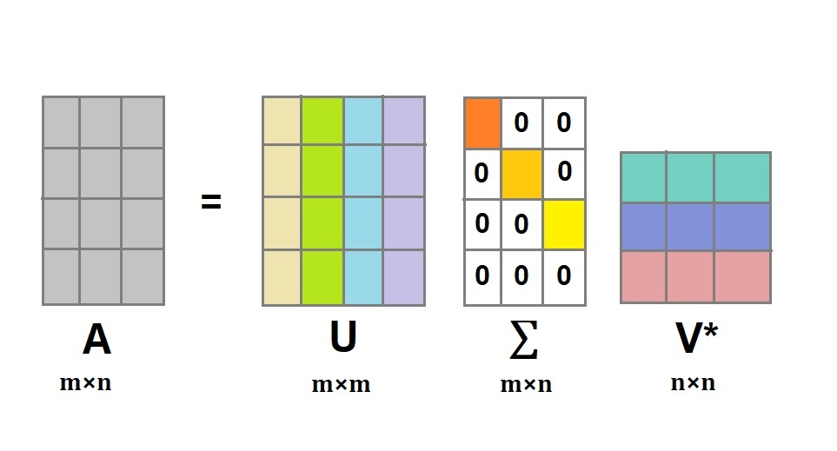

**Latent Dirichlet Allocation**

LDA is a generative model that maps a particular feature to an object based on its latent feature set. It will generate the probability that a particular feature is present in an object and ties back the probabilities to a probability maximization function that determines the mapping. The generative model used in LDA makes it richer in domain knowledge than PLSA, SVD. These generative models are built using background and domain knowledge. Each object has set of features. Observed variables in LDA are n objects and m features. k is the latent features which are unobserved variables. To measure likelihood of a feature in the database Poisson distribution is used to assign the probabilities. ‘Dirichlet’ indicates LDA’s assumption that the distribution of topics in a document and the distribution of words in topics are both Dirichlet distributions. ‘Allocation’ indicates the distribution of topics in the document.

Dirichlet distribution is associated to likelihood of multinomial distribution in the database.

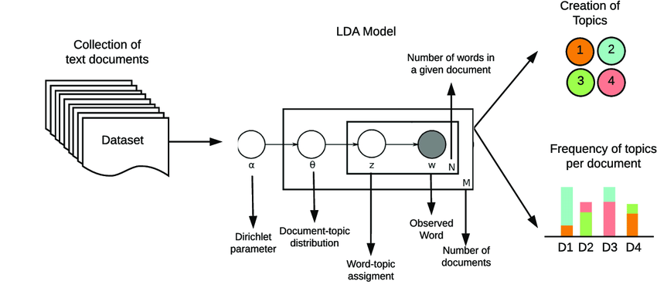

*Sample of LDA performed on a text document database and topic modelling*

**K-Means**

K-means Clustering is a vector quantization approach that divides n observations into k clusters, with each observation belonging to the cluster with the closest mean (cluster centres or cluster centroid), which serves as the cluster's prototype. To analyse the learning data, the K-means method starts with a set of randomly chosen centroids that serve as the starting points for each cluster, and then performs iterative (repetitive) calculations to optimize their positions.

It stops constructing and optimizing clusters if one of the following conditions occurs:

* The centroids have stabilized — there is no change in their values because the clustering has been successful.
* The defined number of iterations has been achieved.

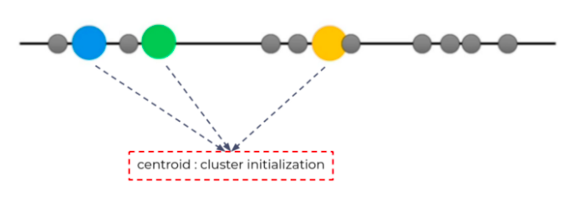

The following steps depict the working of K-Means algorithm:

1. Determine the value “K”, the value “K” represents the number of clusters.
2. Randomly select 3 distinct centroid (new data points as cluster initialization)
3. Measure the distance (Euclidean distance) between each point and the centroid.
4. Assign each point to the nearest cluster.
5. Calculate the mean of each cluster as a new centroid.

Repetition of step 3–5 with the new center of cluster.

**Personalised PageRank**

PageRank algorithm, named after the google founder Larry Page is used to rank the websites as per their connectivity to other webpages. Two major concepts in this algorithm is the ‘Hubs’ and ‘Authorities’. An authority is defined as a node to which many hubs point to. A hub is defined as a node which points to many authorities. These both type of nodes are considered to be of significant value to the structure of the graph. PageRank algorithm attempts to assign a rank to a node in the graph based on its significance to the topology of the graph.

Personalised PageRank is an extension to the normal PageRank in which we choose a set of initial seed nodes, which can be described as nodes that are of points of interests, and find the ranking of the graph based on the given seed nodes. This enables us to modify the similarity and ranking scores based on user preferences on a database.

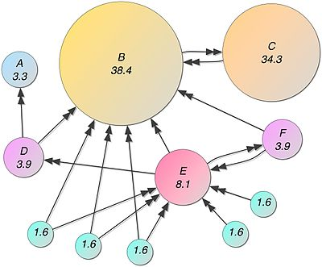

**Support Vector Machine**

Support Vector Machines (SVM) are commonly thought of as a classification strategy, however, they may be used to solve both classification and regression problems. It can handle both continuous and categorical variables with ease. To differentiate various classes, SVM creates a hyperplane in multidimensional space. SVM iteratively generates the best hyperplane, which is then utilized to minimize an error. The goal of SVM is to find a maximum marginal hyperplane (MMH) that splits a dataset into classes as evenly as possible.

The SVM method is an excellent classification algorithm. It's a supervised learning algorithm that's primarily used to categorize data into several groups. A set of label data is used to train SVM. SVM has the advantage of being able to solve both classification and regression issues. To divide or classify two classes, SVM creates a decision boundary, which is a hyperplane between them. SVM is also utilized in picture classification and object detection.

Support Vector

The data points nearest to the hyperplane are called support vectors. By computing margins, these points will better define the separation line. These points are more relevant to the classifier's construction.

### Hyperplane

A hyperplane is a decision plane that distinguishes between a group of objects with distinct class memberships.

Margin

A margin is a distance between the two lines on the class points that are closest to each other. The perpendicular distance from the line to the support vectors or closest points is determined. A bigger margin between the classes is regarded as a good margin, whereas a smaller distance is considered a bad margin.

What is SVM and how does it work?

The main goal is to separate the given dataset as efficiently as feasible. The margin is the distance between the two points that are closest to each other. The goal is to find a hyperplane that has the largest feasible margin between support vectors in the dataset. In the following steps, SVM looks for the largest marginal hyperplane:

1. Create hyperplanes that effectively separate the classes. Three hyperplanes, black, blue, and orange, are shown on the left side of the illustration. The blue and orange classes exhibit more classification errors, while the black class correctly separates the two classes.
2. As illustrated in the right-hand figure, choose the right hyperplane with the highest segregation from the nearest data points.

**Decision Trees**

The nature of the classification issue (i.e. number and type of classes), the (statistical) qualities and the number of input features (e.g. number of spectral bands), and processing efficiency all influence the choice of classification methods.

Decision trees (DT) are one of the most intuitive classification techniques, and they're a fantastic place to start if you're new to image classification. The DT is essentially a series of decision rules for converting continuous data, such as spectral information from an image, into discrete thematic data, such as a land cover class. If a pixel's spectral information (or spectral alterations like vegetation indices) meets certain criteria, it will be allocated to a land cover class. Its structure, which is organized hierarchically in simple binary (yes/no) decisions, gives it the name "Decision Tree."

For classification and regression, Decision Trees (DTs) are a non-parametric supervised learning method. The goal is to learn simple decision rules from data attributes to develop a model that predicts the value of a target variable. A tree is an approximation of a piecewise constant.

**VA Files Indexing**

VA files or Vector Approximation files are a form of indexing structure used to locate images easily in higher dimensions. Higher dimensional objects are usually difficult to perform searches on due to their large computational complexities. So, in order to escape the complex and costly computations (dimensionality curse), VA files are used to prune the search space to a subset of the database for faster querying.

The idea behind VA Files is portioning of the space instead of the data. Each vector is approximated based on the cell in which it lies. This approximation is called a “signature” of the file and is used to filter on the search space. While evaluating the query, all approximations or signatures are scanned and only those that are having a good chance to be in the neighbourhood of the given query object are considered. The solution is searched only in this sub space instead of the entire space.

The vector approximation is generated as follows:

•Each feature of the image space is divided into equally distributed regions based on their values.

•Each region is then assigned a particular value based on the total number of bits.

•This process is repeated until all the features are divided into sub regions based on the number of bits.

•The final string is a concatenation of the approximated arrays, and the resulting VA-file is returned to the output.

The query is performed as follows:

•A query image is given by the user.

•The query image is then featurized as per the stored database model.

•A signature file is then computed for the query which is used as a filter to select the potential candidates for comparison.

•The actual distance from the query to the objects is computed only for the potential candidates and the top – k images from them are returned as the outputs.

**Local-Sensitive Hashing**

In approximate similarity search, locality sensitive hashing (LSH) is a widely used approach.

One of the most prominent approximate nearest neighbors search (ANNS) methods is Locality Sensitive Hashing (LSH).

It's a hashing algorithm at its foundation, allowing us to put comparable things into the same hash buckets. So, given an impossibly large dataset, we use the hashing method to sort all of our things into buckets.

Unlike other hashing functions, which try to reduce hashing collisions, LSH algorithms strive to increase them. Similar vectors produce the same hash value and are bucketed together as a result of LSH. Dissimilar vectors, on the other hand, should not give the same hash value, resulting in them being placed in different buckets.

There are three steps to conducting a search with LSH:

1. All of our vectors should be indexed into their hashed vectors.

2. Describe our query vector (search term). The same LSH function is used to hash it.

3. By calculating the Hamming distance between our hashed query vector and all other hash buckets, we can determine which is the closest.

**2. Goal Description (Problem Specification)**

The project has been divided into four main tasks. They are defined as follows:

1. **Task 1** - The aim of this task is to design a program that takes two folder of images, one of the three feature models, a user-specified value of X, a user-specified value of k, and one of the classifier models (SVM, decision trees, PPR based classifier) chosen by the user and outputs false positives and miss rates.
2. **Task 2 -** The aim of second task is to design a program that takes two folder of images, one of the three feature models, a user-specified value of Y, a user-specified value of k, and one of the classifier models (SVM, decision trees, PPR based classifier) chosen by the user and outputs false positives and miss rates.
3. **Task 3 –** Third task is to implement a program that takes two folder of images, one of the three feature models, a user-specified value of Z, a user-specified value of k, and one of the classifier models (SVM, decision trees, PPR based classifier) chosen by the user and outputs false positives and miss rates.
4. **Task 4 -** The fourth task is to implement locality sensitive hashing tool and implement similar image search using index structure.
5. **Task 5 -** Task 5 involves implementing a VA-file Index tool that stores the given folder of images in a VA-file data structure and when given an image and t, the VA-file index tool outputs t most similar images and also outputs number of buckets searched as well as the unique images considering false positives and miss rates.
6. **Task 6 -**
7. **Task 7 -**
8. **Task 8 –**

**3. Assumptions**

As the project is being developed as a proof of concept, there are several assumptions that have been made in-order to achieve the results. They are as follows:

# DESCRIPTION OF THE PROPOSED SOLUTION

In order to quantitatively reduce the dataset size and find latent features, the proposed solution is to transform the image in-order to obtain the latent features which are then represented into vector formats, enabling us to reduce the dataset size by representing only the top significant features and ignoring the insignificant ones, the premise being that the significant features represent the database effectively without losing a lot of information. There are four major dimensionality reduction techniques that have been used in this project. They are as follows:

1. Singular Value Decomposition
2. Principal Component Analysis
3. Latent Dirichlet Allocation
4. K-Means

All calculations and development of the code has been done using the Python language on Visual Studio/PyCharm IDE and debugging on Jupyter notebooks IDE.

There are two major process flows within the proposed solution architecture, one is to generate the feature vectors for all the images present in the folder. The second one is to generate the feature vector for the given image and calculate the similarity scores based on the task at hand. Also, code design for each given task is as described below:

**1. Task – 1**

|  |
| --- |
|  |

The pseudocode for Task – 1 is as follows:

**2. Task – 2**

The block diagram for task – 2 is as follows:

|  |
| --- |
|  |

Task – 3

**3. Task – 3**

The pseudocode for task 3 is as follows:

|  |
| --- |
|  |

**4. Task – 4**

|  |
| --- |
|  |

|  |
| --- |
|  |

|  |
| --- |
|  |

1. **Task – 5**

1. **Task – 6**

# DESIGN DECISIONS

For Personalized Page Ranking Algorithm, we have used the power iteration method.

In the power iteration method, we take a Web Graph of N nodes where nodes represent pages and edges represent hyperlinks. For our project we have used the adjacency matrix as this Graph.

It is a simple iterative scheme where,

* Suppose there are N webpages,
* Initialize =
* Iterate: =M.
* Stop when |-| < ε

Where r is a ranking vector. We start with a guess of our rank vector and then we multiply it by M and iterate it continuously until the change in the values of r becomes constant. The final result of the algorithm gives us the pagerank scores.

Design Decisions and details noted while program execution:

* It has been noted that the number of bits “b” value, must be provided in such a way that it is a multiple of the number of dimensions of the feature model chosen. (i.e., If Color Moments is chosen as feature model, then the min number of bits must be 192*2 = 384). So, the optimal values for the models have been noted below:

|  |  |  |
| --- | --- | --- |
| Model | Number of bits to be represented for each dimension in VA | |
| 1st Optimal Value | 2nd Optimal Value |
| Color Moments | 786 (192*4) | 576 (192*3) |
| ELBP | 12288(4096*3) | 16384(4096*4) |
| HOG | 7056(1764*4) | 8820(1764*5) |

* For VA files, distance method chosen is L2-norm or Euclidean norm, as it has been established via multiple runs that computing the Euclidean distances is fastest and provides reliable accuracy.
* It has also been noted that with increasing the VA file size, the search subspace decreases. However, the benefits of having a larger VA file diminishes after the 6th multiple. For best results, any multiple between 3 and 5 is preferred.

Design decisions for implementing SVM:

There can be some objects which will not be classified, and their prediction values will be negative. So those images are classified at the latter stage by comparing the negative values and taking the lesser negative prediction value.

# INTERFACE SPECIFICATIONS

The entire code has been developed and been tested using Python programming language, running on PyCharm and VS Code IDEs. The main.py script is the primary runtime script for the entire code.

The instructions to run the program are as follows:

1. Navigate to the src folder in the deliverable.
2. Open the “config.config” file in any IDE of choice (Visual Studio Code).

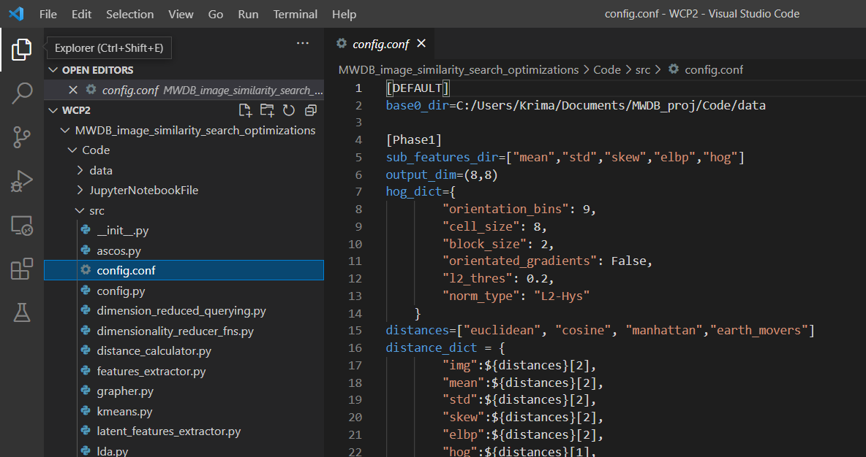

1. Edit the path variables as necessary in “base0_dir”.



1. Navigate to main.py script in the Code folder

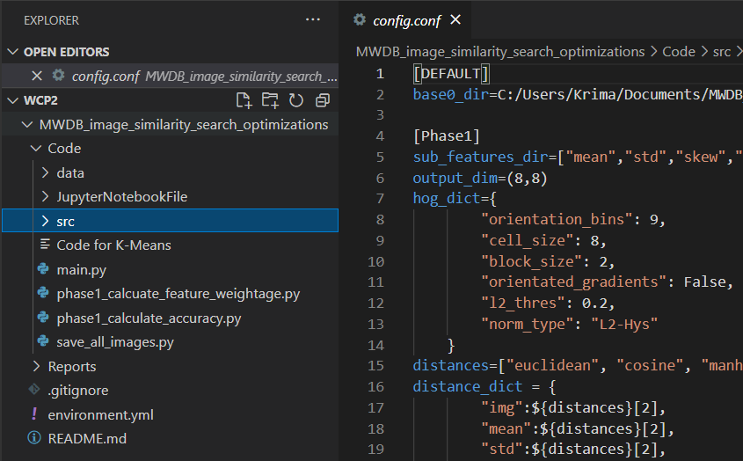

1. Run the “main.py” file
2. All computed outputs will be in the respective Output folders.

# OUTPUTS

1. **Output for Task – 1 & 2**: (These are the csv files that contain the latent features)

2. **Output for Task-3&4**: (We get a subject-subject or type-type similarity)

3. **Output for Task – 5:** Output of ‘k’ similar images

4. **Outputs for Task- 6 and 7:**

6. **Output for Task- 8:**

5. **Output for Task- 9:**

# SYSTEM REQUIREMENTS

The main requirements for the Image Similarity program to run is the python programming language and any IDE of choice. Python can be installed in the system using the given steps:

1. Open web browser of choice and navigate to <https://www.python.org/downloads/>
2. Select the most recent/desired version of python version.
3. After the EXE file finishes downloading, click on Run.
4. Follow the instructions on the screen to setup python on the machine.

Python usually comes with a package manager called “pip”. This can be used to install further dependencies. First is the IDE Jupyter notebooks. This can be installed with the command:

pip3 install notebook

After installing Jupyter, we have to install the required libraries for the program. Each library can be installed using a standard command

pip install <library name>

*(Replace with respective library)*

1. **Numpy:** This is the standard python library for dealing with arrays. It can be installed with the command : pip install numpy
2. **Pandas:** Pandas library enables to store arrays as Dataframes, which make it easier to work with multi-dimensional data.
3. **Matplotlib:** This is the library required to visualize the vectorized images as normal 2-D images on screen.
4. **Math:** Basic math functions library. Used for rounding to the nearest decimal places.
5. **Scipy:** Library used to perform scientific calculations. In this instance it is used to access skew function.
6. **Skimage:** This library is used to compute the ELBP and HOG vectors. It contains many feature vectorization methods that can be used to extract features from images.
7. **PIL (Pillow):** This is the python imaging library. It contains many functions that make working with images easier.
8. **Glob:** This library is used to create iterable lists of file paths that can then be used in standard looping functions.
9. **OS:** Standard python library that contains functions to deal with operations related to Operating systems. It is used to access filepaths and write to files.

Also, the above dependencies are mentioned with a view in mind that the underlying operating systems is Windows. In case of MAC or Linux, the installation procedures may differ slightly.

# RELATED WORK

There have been references to several related works in achieving the final outputs of the program.

There have been references to several related works in achieving the final outputs of the program.

For implementing VA-files Index Tool the major point of reference is Stephen Blott and Roger Weber(1997)[1] work on “A Simple Vector-Approximation File for Similarity Search in High Dimensional Vector Spaces”. In this paper the authors discuss many similarity measures used in multimedia databases and decision-support systems are based on high-dimensional underlying vector spaces. For such spaces, data-partitioning index approaches (for example, grid files, R-trees, and their variants) function well for low-dimensional spaces but struggle as dimensionality rises. The 'dimensional curse' has been coined to describe this issue.

For implementation Locality-sensitive hashing the major point of reference is Alexandr Andoni and Piotr Indyk (2008)[2] work on “Near-Optimal Hashing Algorithms for Approximate Nearest Neighbor in High Dimensions”. In this paper, the authors offer a query time of O(dn 1 c2/+o(1)) and space of O(dn + n 1+1 c2/+o(1)) approach for the c-approximate closest neighbor problem in a d-dimensional Euclidean space. This is remarkably identical to the lower bound for hashing-based algorithms found previously in (R. Motwani et al., 2006). It also presents a space-saving variant of the technique that utilizes dn+n log O(1) n space and has a query time of dn O(1/c2). Finally, practical variants of the methods for the Leech lattice that use fast bounded-distance decoders.

Another paper referred to implement VA files is Roger Weber, Hans-J¨org Schek, and Stephen Blott(1998)[3] work on “A Quantitative Analysis and Performance Study for Similarity-Search Methods in High-Dimensional Spaces”. The author presents the vector-approximation file (VA-File) is introduced in this study for similarity search in high dimensional vector spaces. The VA-File solves the dimensional curse by employing the filter-based technique of signature files rather than the data-partitioning methodology of traditional index approaches. Space, not data, is separated into cells, and vectors are allocated approximations based on which cells they lie in. These modest, bit-encoded approximations are stored in a VA-File. Nearest-neighbor queries only need to visit a fraction of the vectors by scanning all of the smaller approximations first.

For Implementing SVM classifier based relevance feedback the major point of reference is Lokesh Setia, Julia Ick, Hans Burkhardt()[4] work on “SVM-based Relevance Feedback in Image Retrieval using Invariant Feature Histograms”. In this paper it is given that Relevance Feedback is an intriguing method for improving the performance of Content-Based Image Retrieval systems even when just low-level features are used. Using Invariant Feature Histograms, we compare the efficiency of one class and two class Support Vector Machines in content-based image retrieval. In both situations, we discuss our methodology for performing Relevance Feedback and present positive findings on a selection of MPEG-7 content datasets.

For implementing Decision tree based relevance feedback the major point of reference is MacArthur, Brodley and Chi-Ren Shyu, "Relevance feedback decision trees in content-based image retrieval,"*(*2000)[5]. The authors state that Finding feature representations of images in databases has taken a significant amount of time and effort in order to enable content-based image retrieval (CBIR). Relevance feedback is a strategy for enhancing retrieval precision over time by allowing the user to convey implicitly to the system which of these qualities are and are not important. We propose a relevance feedback retrieval system that learns a decision tree for each retrieval iteration in order to discover a common thread between all images identified as relevant. This tree is then used as a model to predict which of the unseen photos the user is unlikely to want. We assess our method using HRCT pictures of the lung.

For identifying m most significant subjects using Personalised Pagerank measure, the major point of reference was Shengyu Huang, Xinsheng Li. K, Selcuk Candan, Maria Luisa Sapino(2013)[6] work on “Reducing seed noise in Personalised Page Rank”. In this paper, the authors have concluded that conventional personalised page rank algorithm associate unnecessarily high bias to the seed nodes and this negatively affects the node rankings when the seed set is incomplete or noisy. To deal with this problem the authors have proposed alternative robust personalised pagerank algorithm that eliminates the potential noise in the seed set. The experiment results confirm that the seed-set maximal approach is reuse promoting in that it is possible to divide the work relative to individual seed nodes and teleportation discounting technique provides additional robustness against noise introduced during graph-partitioning (and block diagonalization) based approximate random walk computation processes.

# CONCLUSIONS

# BIBLIOGRAPHY

[1] Stephen Blott and Roger Weber,(1997). A Simple Vector-Approximation File for Similarity Search in HighDimensional Vector Spaces. http://citeseerx.ist.psu.edu/viewdoc/summary?doi=10.1.1.29.9708

[2] Alexandr Andoni and Piotr Indyk(2008). Near-Optimal Hashing Algorithms for Approximate Nearest Neighbor in High Dimensions.

[3] Roger Weber, Hans-J¨org Schek, and Stephen Blott(1998). A Quantitative Analysis and Performance Study for Similarity-Search Methods in High-Dimensional Spaces. In Proceedings of the 24rd International Conf erence on Very Large Data Bases (VLDB ’98), pp. 194-205. 1998.

https://dl.acm.org/doi/10.5555/645924.671192

[4] Lokesh Setia, Julia Ick, Hans Burkhardt. SVM-based Relevance Feedback in Image Retrieval using Invariant Feature Histograms. 2005

[5] MacArthur, Brodley and Chi-Ren Shyu, "Relevance feedback decision trees in content-based image retrieval," 2000 Proceedings Workshop on Content-based Access of Image and Video Libraries, 2000, pp. 68-72, doi: 10.1109/IVL.2000.853842.

[6] Huang, S., Li, X., Candan, K.S. et al. Reducing seed noise in personalized PageRank. Soc. Netw. Anal. Min. 6, 6 (2016). https://doi.org/10.1007/s13278-015-0309-6